13/04/2021. UFO high bay repair
Today, one customer has two UFO high bay not working and want to repair them, they are 240W UFO high bay.
1, loosen the screws on the lens and remove the lens.
2, find it uses SMD3030 led chip, 6V 1W, the arrangement of led chips are 9s40p, so the normal voltage is about 54V.
3, test the positive and negative terminal voltage, found the test value is zero.
4, turn off the power, clean the wiring head, and retest, found the test value is still zero.
5, make sure it is the driver faulty, the driver is IP67 and can not repair, need to replace it.

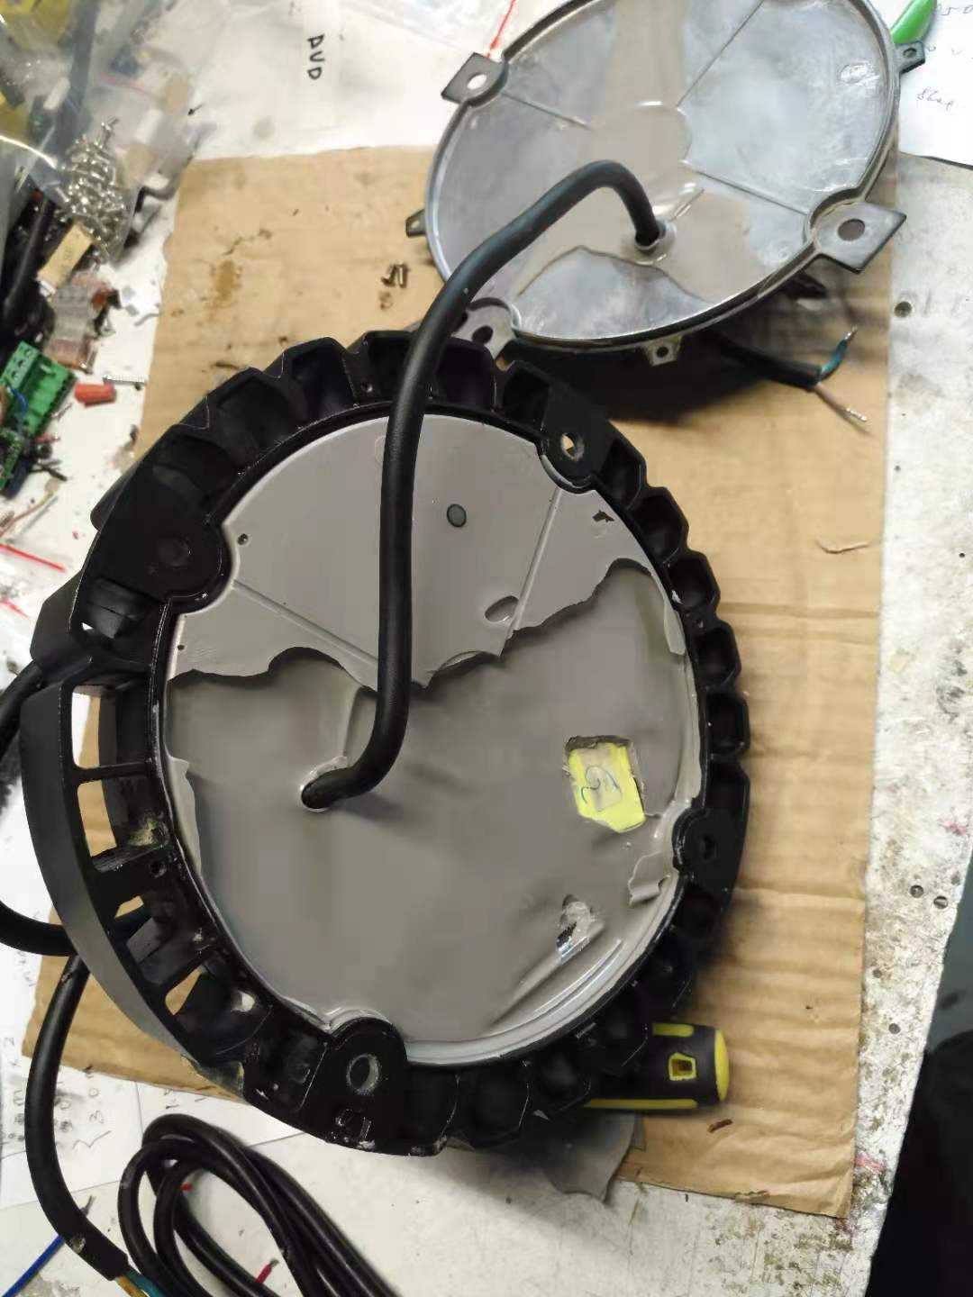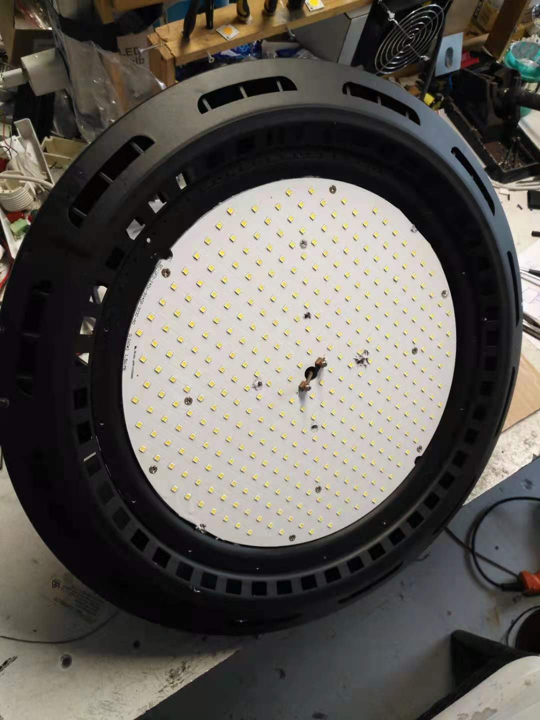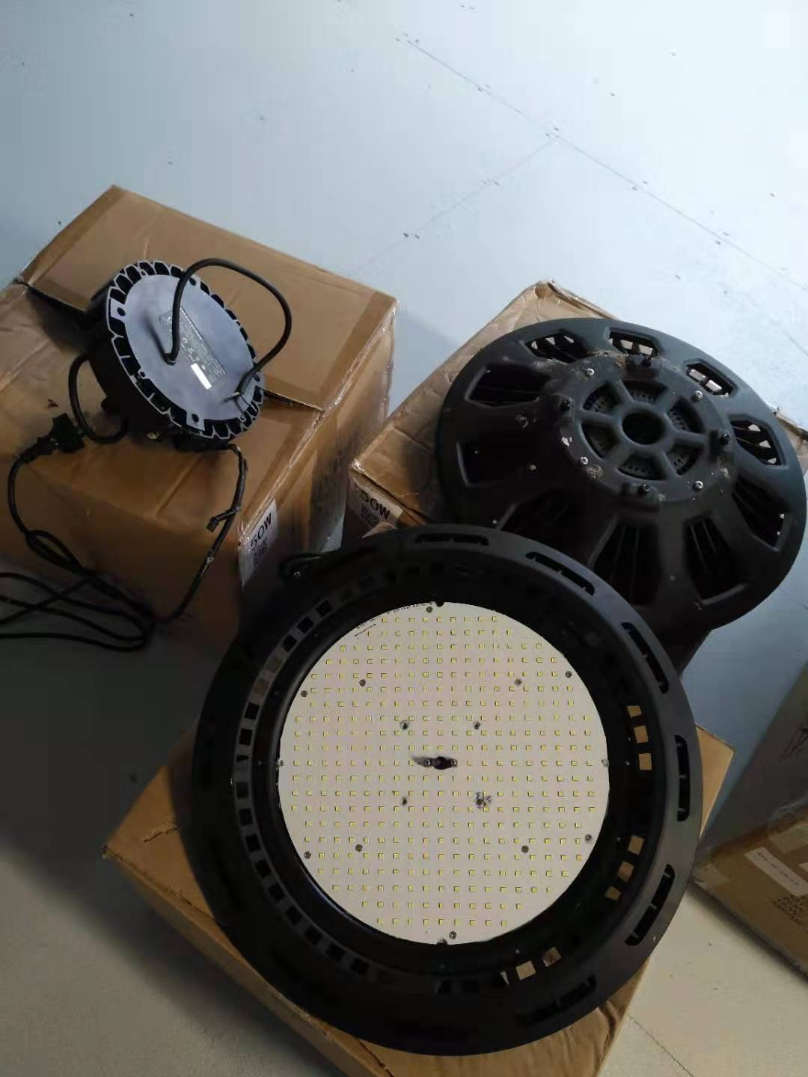

5/05/2021. Downlight COB repair

Today one electrician brought in one corner COB light to fix it, this is one 30W 4000k COB downlight, current is 900mA.
1, plug it in and test it, found only half COB chip could light, and flicked, so to know the chip was faulty.
2, removed the lightshade and replaced the led chip.
3, tested again, the light was ok.

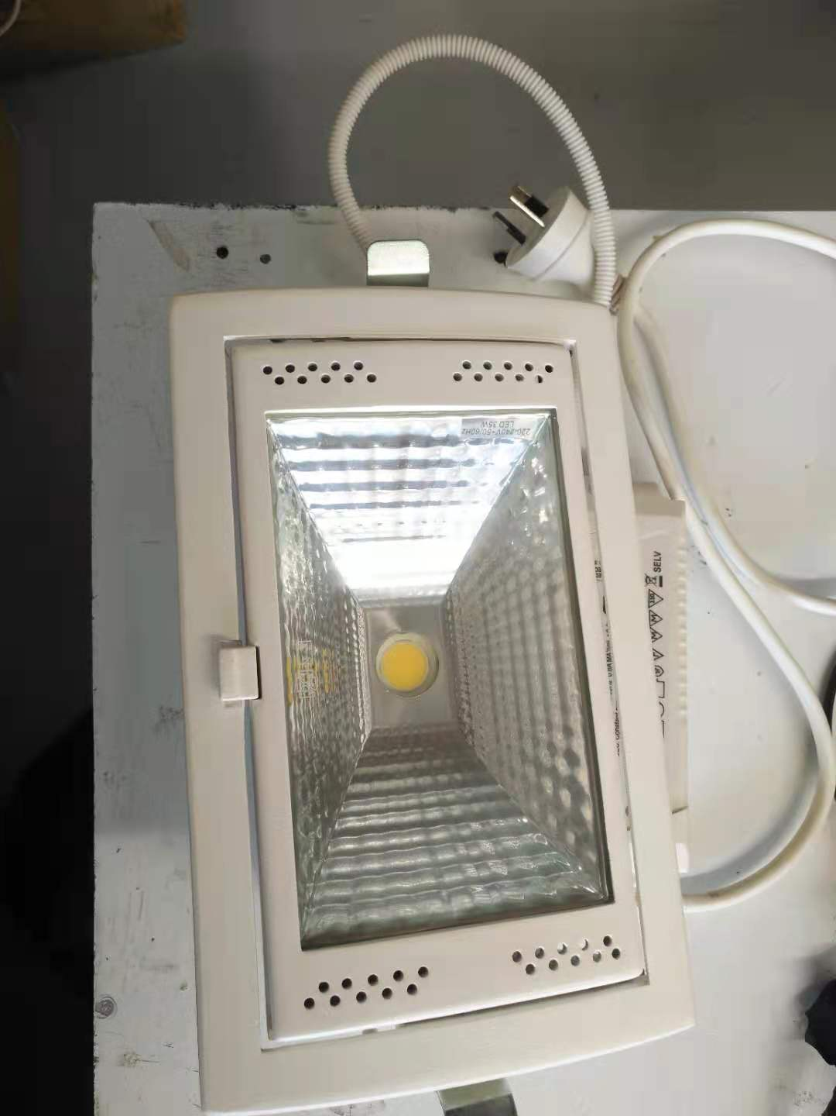
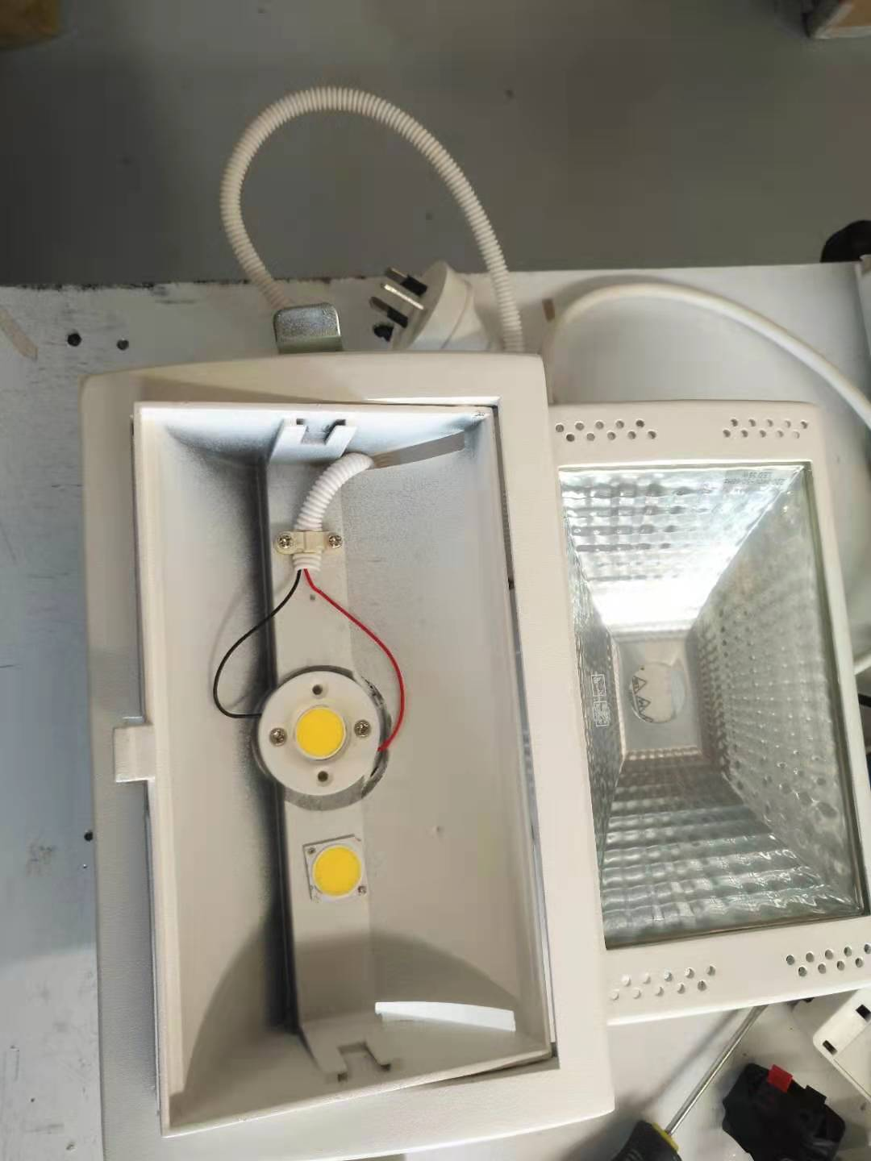
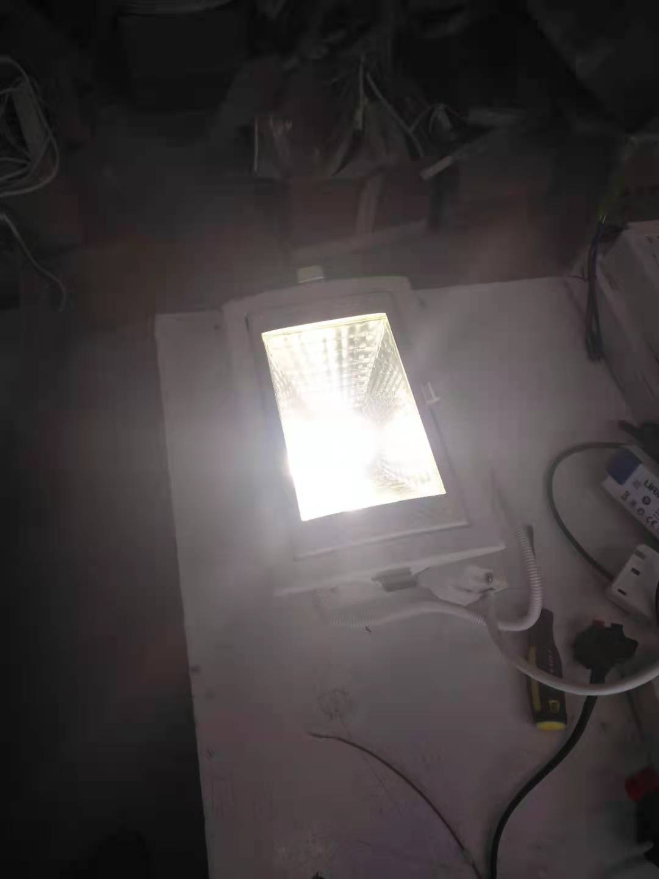

16/05/2021. Ceiling light repair

Today one customer took three pieces ceiling lights to repair, because it is not easy to look for them as the same size around the light shops, these are some ceiling lights, 18W, use the linear constant current driver, linear constant current driver is different from normal constant current driver, the current of this driver is very low, but the voltage is very high.
1, looked the board and found some chips were broken down.
2, changed these chips and tested, they were ok.

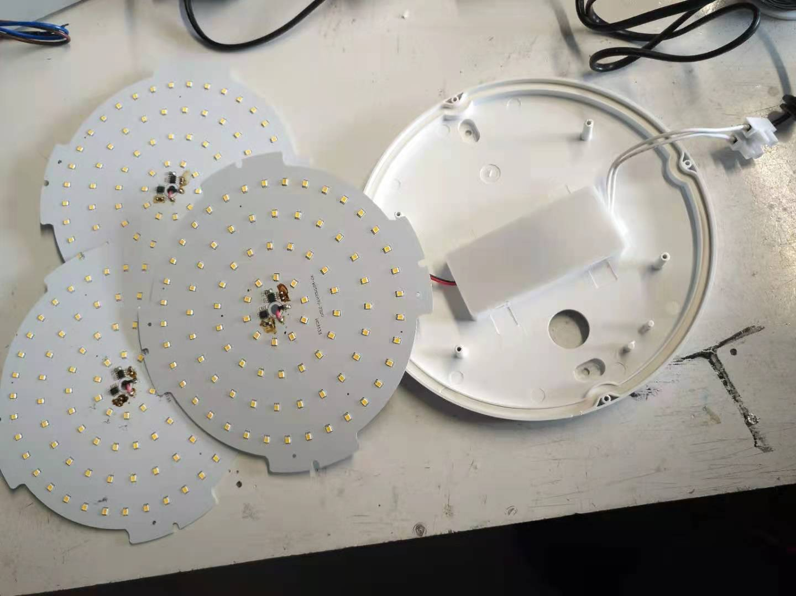
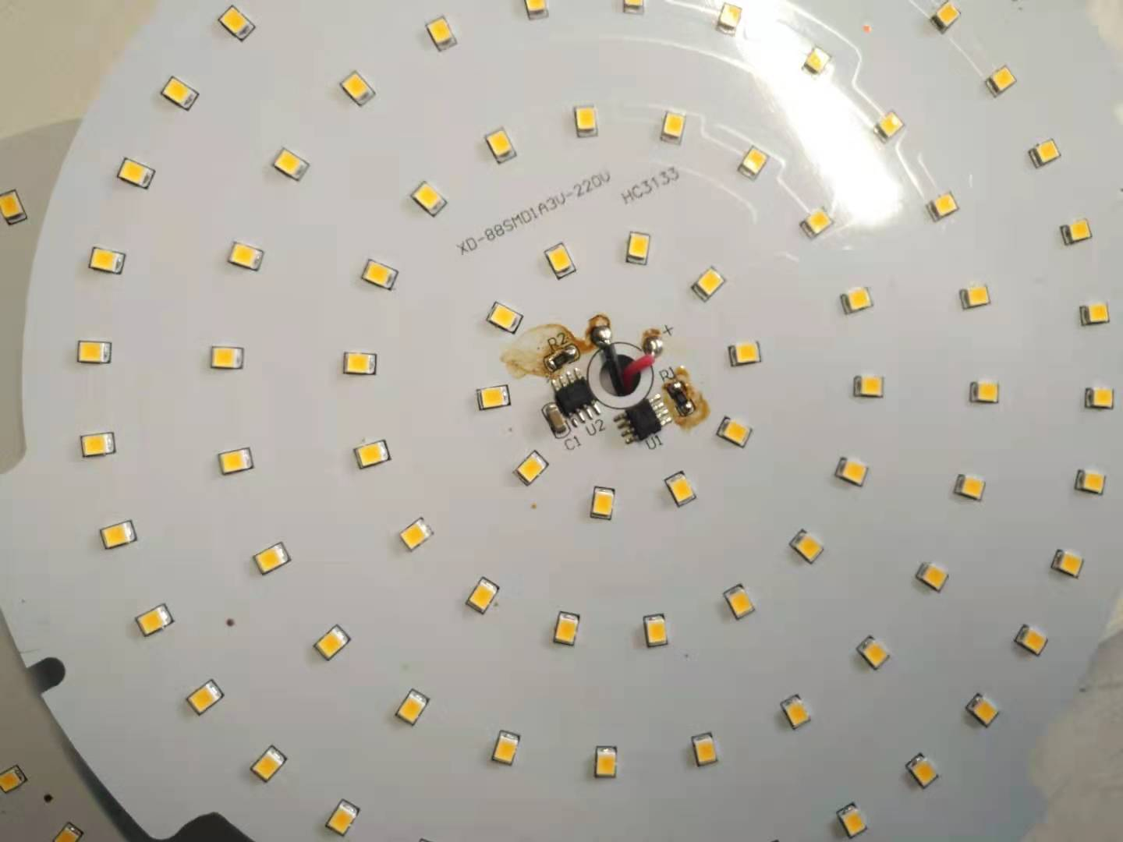
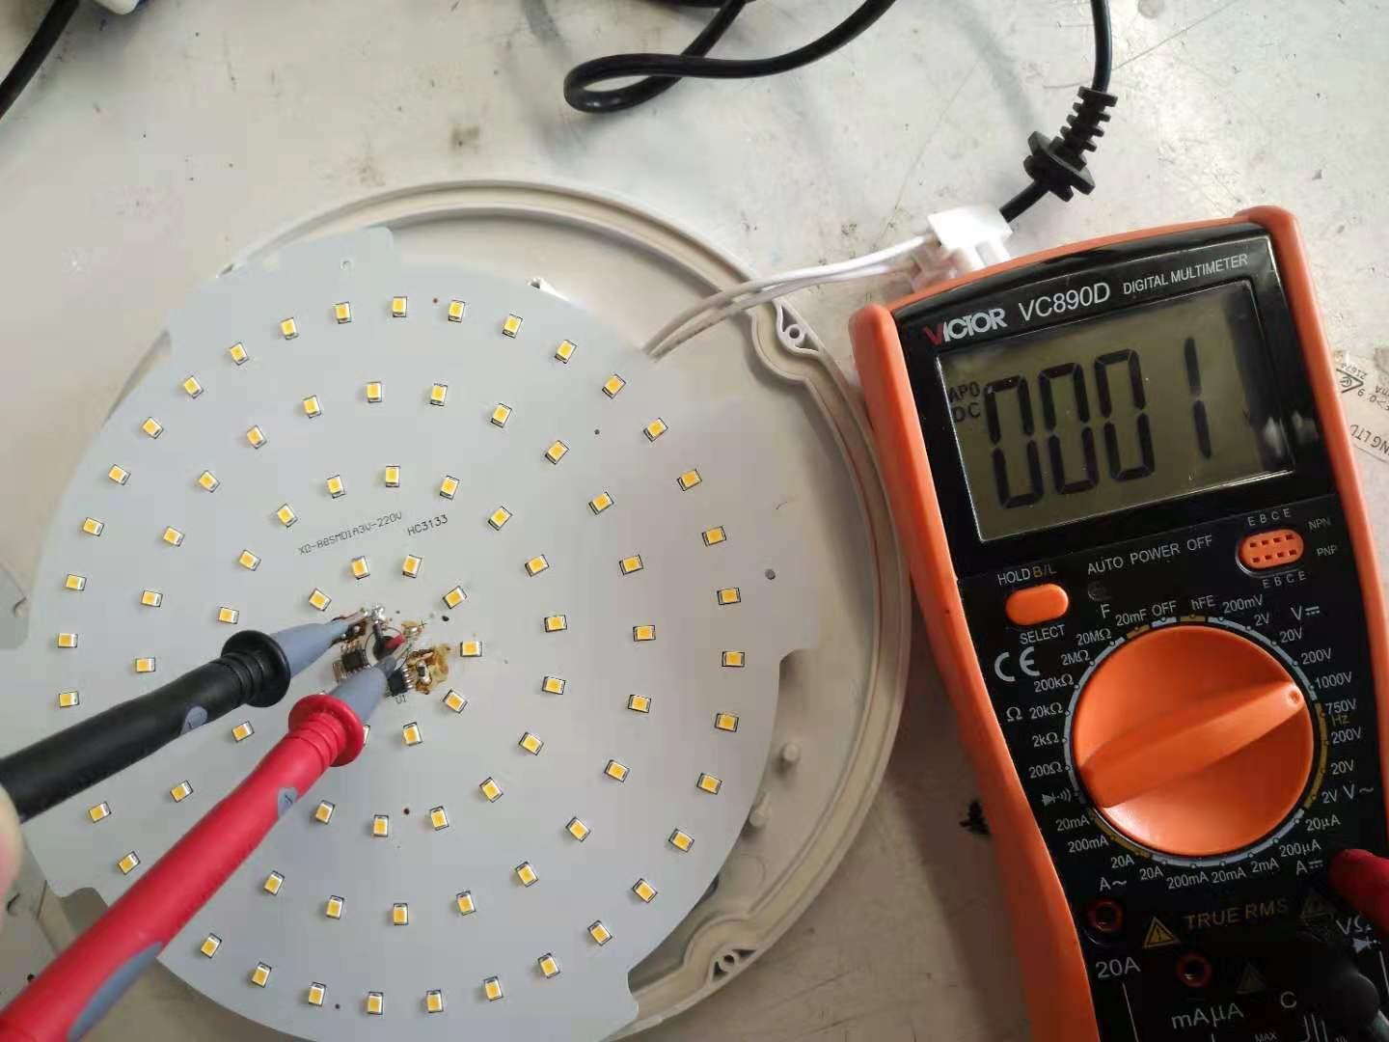
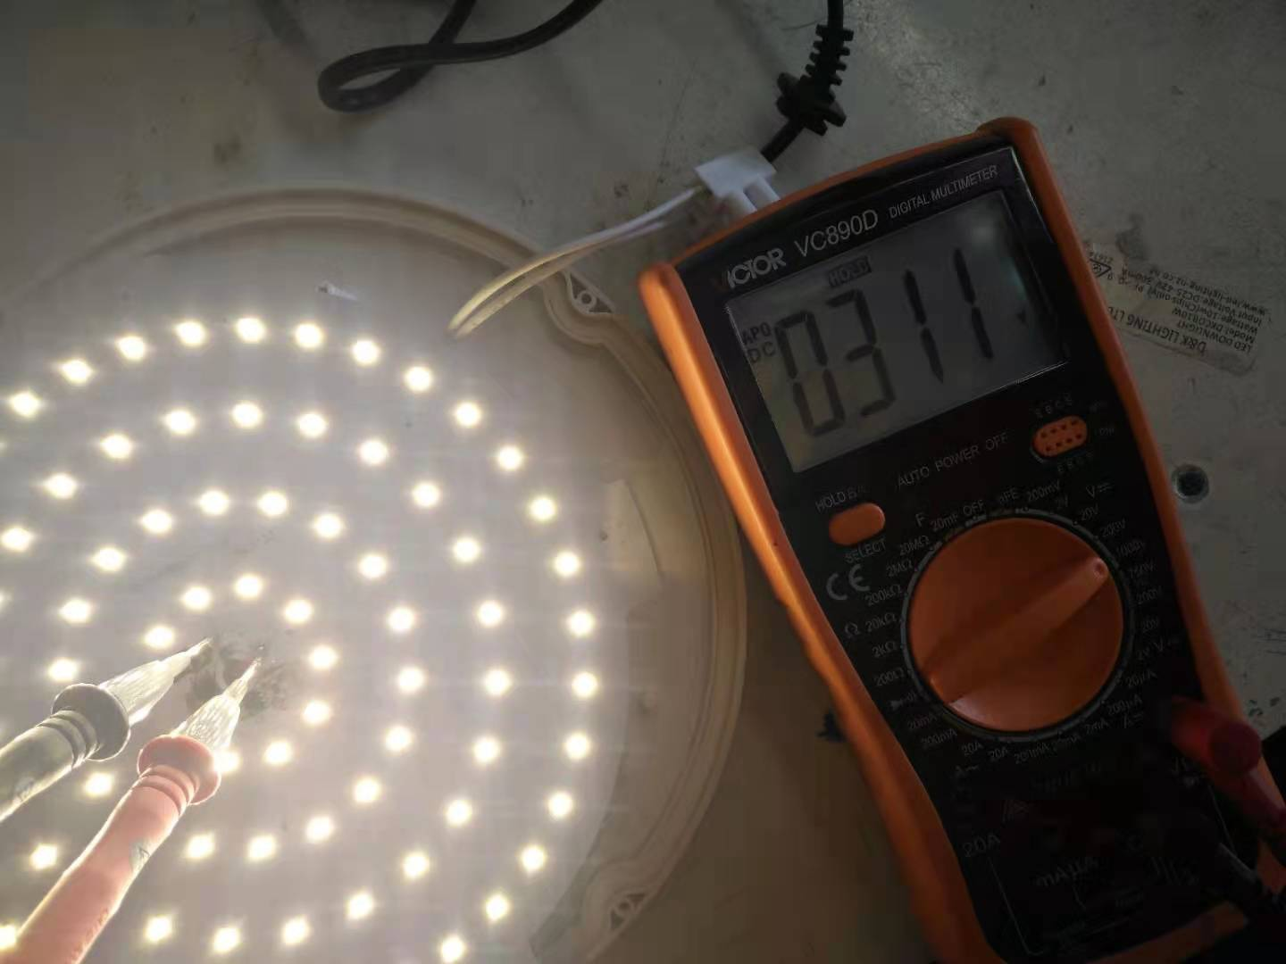

1/6/2021. Flood light COB repair

Today, one customer took one flood light to repair, this is 100w flood light, the chip is 10s10p, the voltage is about 32v, in appearance, the chip was worn.
1, plug it in and tested it, but it did not light up.
2, removed the screws, tested the driver voltage, found the driver was faulty.
3, changed the chip and the driver, it was ok.
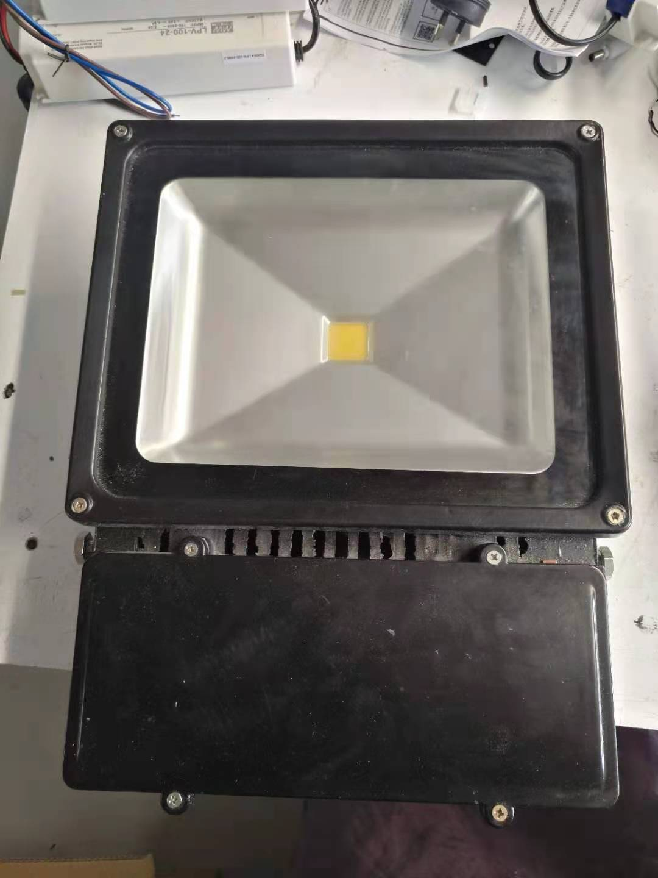
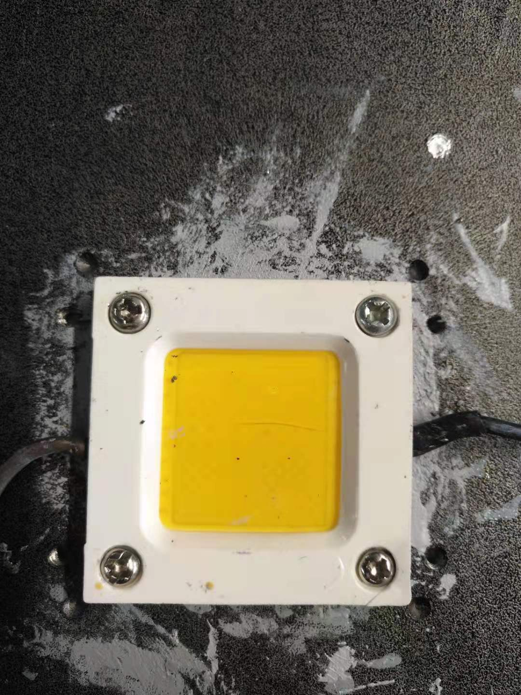
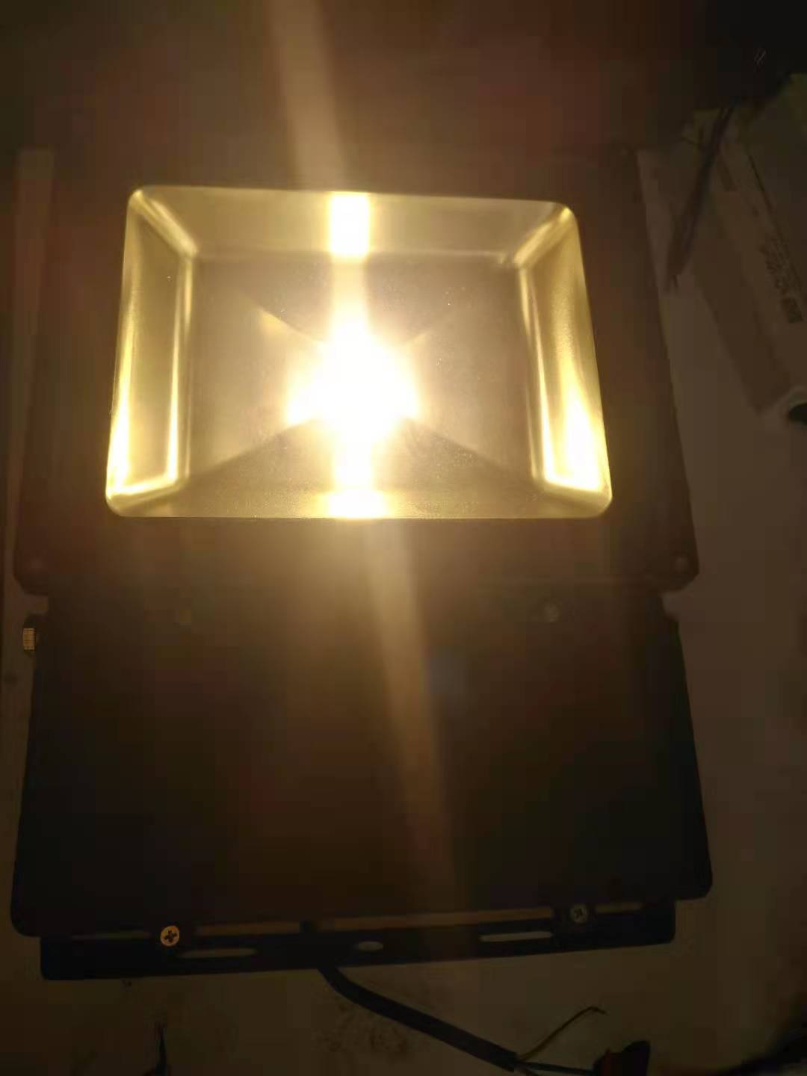

16/06/2021 one up and down cob light repair
Today, one customer took one up and down cob light to repair, this is 2*30W cob light, the chip is 10s6p, the voltage is about 32v, in appearance, the chip was worn.
1, plug it in and tested it, but it did not light up.
2, removed the screws, tested the driver voltage, found the output voltage was 1.2V,so the driver was faulty.
3, changed the chip and the driver, it was ok.

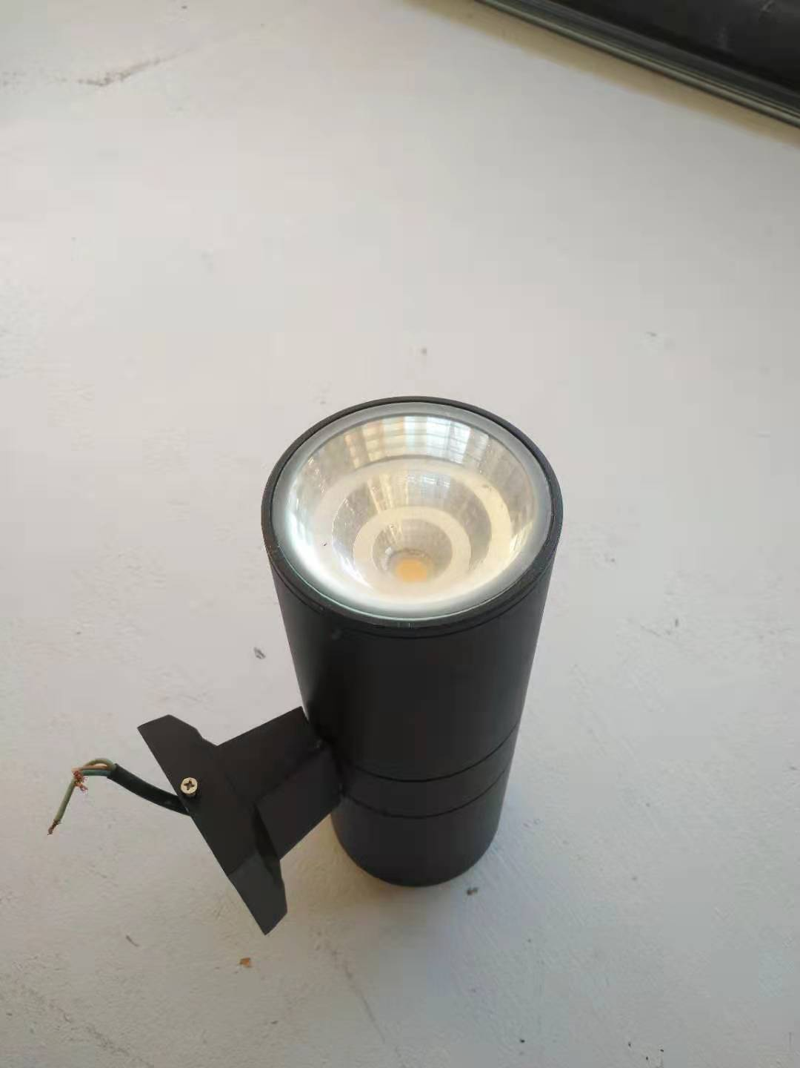
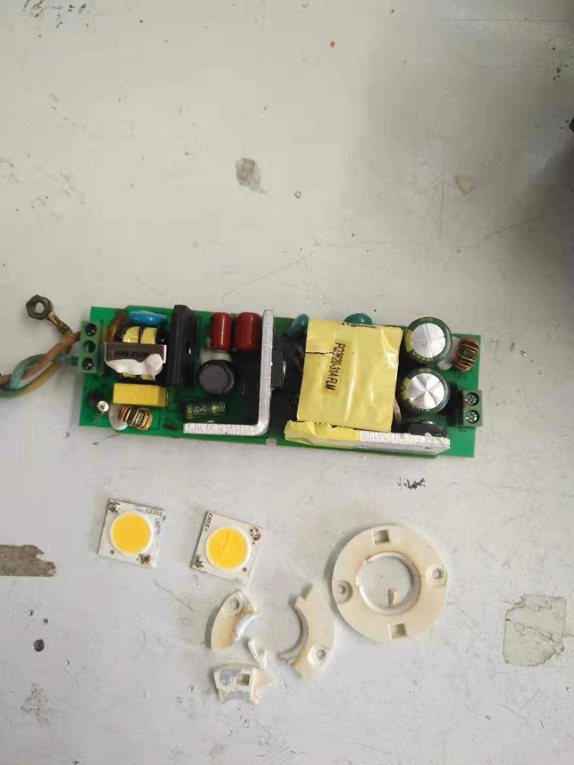
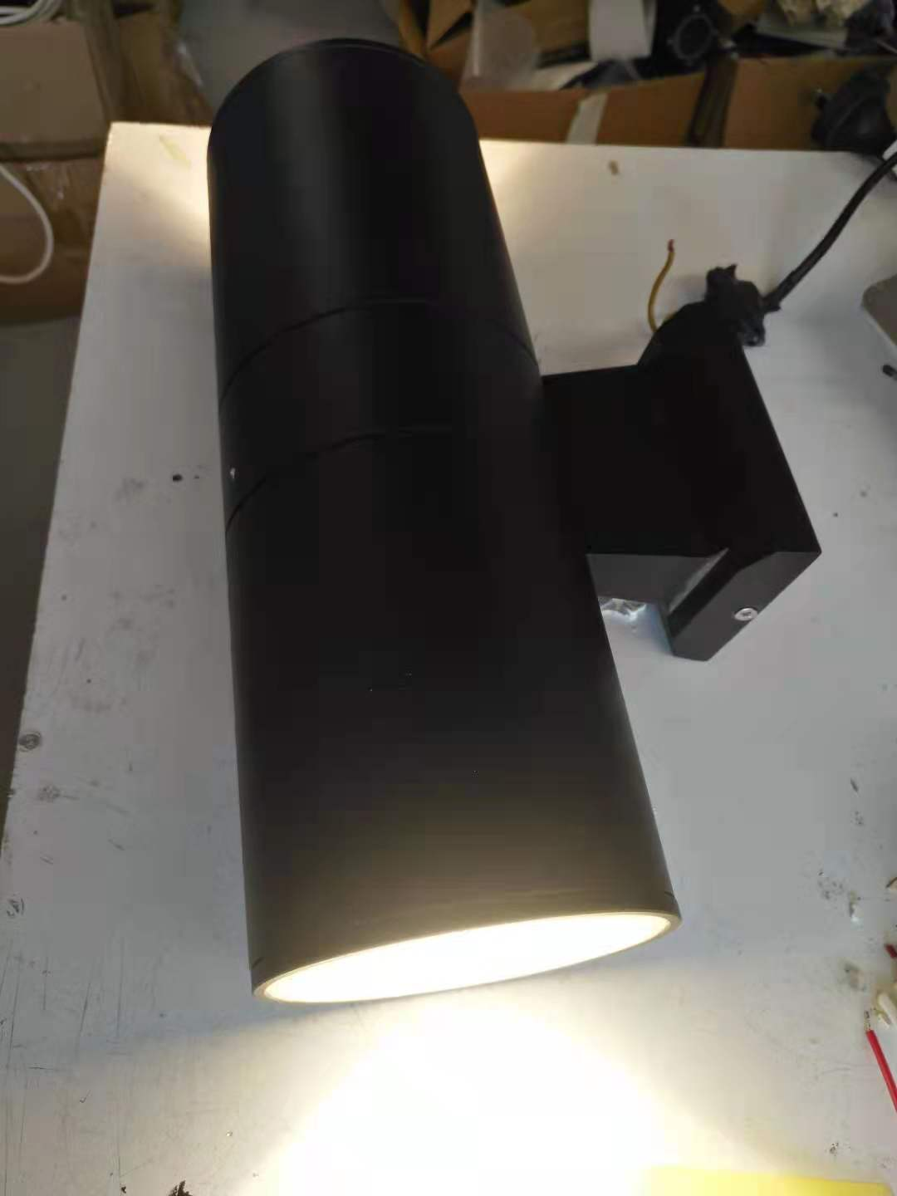

28/06/2021 one 1200*600 panel light repair
Today, one customer took one 1200*600 pane light to repair, the power is 60W, the current is 1500mA, the voltage is about 40v, CCT is 3000K.
1, plug it in and tested it, only one side some chips light up.
2, removed the screws, tested the driver voltage, the driver was ok.
3, tested the chips, found the chips were faulty.
4, changed the chips, it was ok.

